Instructions for DIY Advent Wreath

Materials Required:
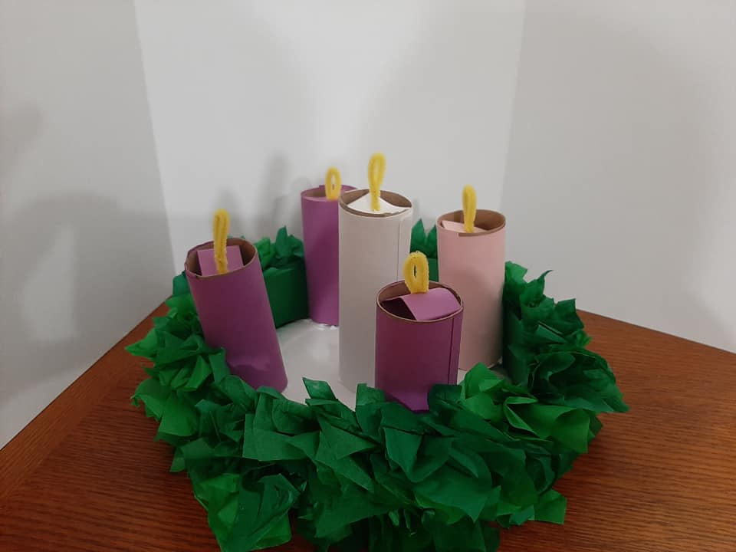

1 9-inch paper plate
4 toilet tissue tubes and 1 5-inch section of paper towel tube (or 5 toilet tissue tubes)
3 4-1/4x11-inch pieces green cardstock
3 4x8-1/2-inch pieces purple cardstock
1 4x8-1/2-inch piece pink cardstock

1 5x8-1/2-inch piece white cardstock
5 2x5-inch pieces cardstock

5 yellow pipe cleaners
16 6x15-inch pieces of green tissue paper
Scissors and glue

Procedure: (There is a diagram at the end of this document explaining hot dog folds and hamburger folds.)
- Hot dog fold the 3 pieces of green cardstock. Overlap the end of the first piece on the second piece by about 2 inches. Use a dab of glue to hold in place. Repeat with the second and third pieces, so that your strip is about 29-30 inches long. Make a mark on one side a few inches from the end of the strip so that you have a piece 27 inches long. This will form the wreath.
Fun math fact: Your paper plate is about 9 inches in diameter. This strip will fit inside the edge, so less than 9 inches. The distance around the plate (circumference) is the diameter times pi (3.14 inches). So a little less than 9 times a little more than 3 equals 27.

- Stack the pieces of tissue paper (all 16 or 8 at a time). There are different shades of green. They can be mixed. Hot dog fold the stack and cut along the crease. They don’t need to line up perfectly and the cut doesn’t need to be exact. Your tissue papers will now be about 3x15. Hamburger fold the stack and cut along the crease so your pieces are about 3x7.5. Hamburger fold the stack again and cut along the crease, so your pieces are about 3x3.75.

- Lay out your green cardstock strip. Spread some glue over a small area and gently scrunch or pinch a piece of tissue and glue in place. Repeat this process until the strip is covered, leaving the end open to form a circle. The tissue pieces will be fluffy, so you don’t need to put them too close together. Try to get more glue on the strip than you get on the table or yourself! Keep gluing until one side of the strip is covered, except for the end.
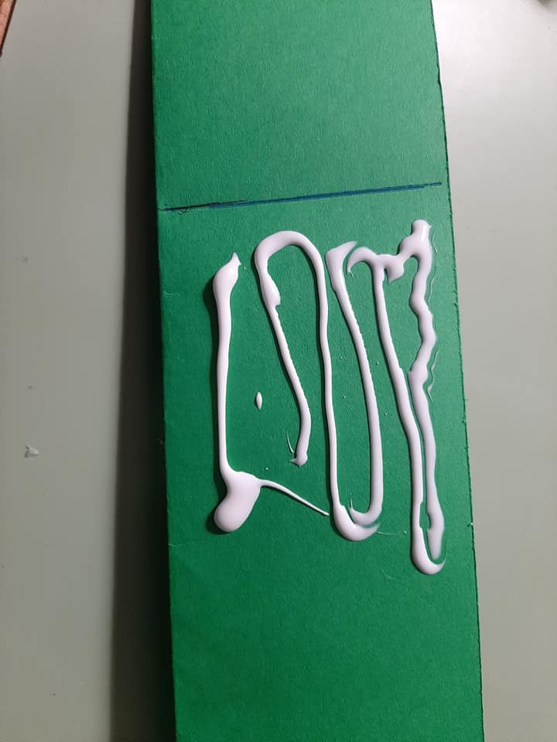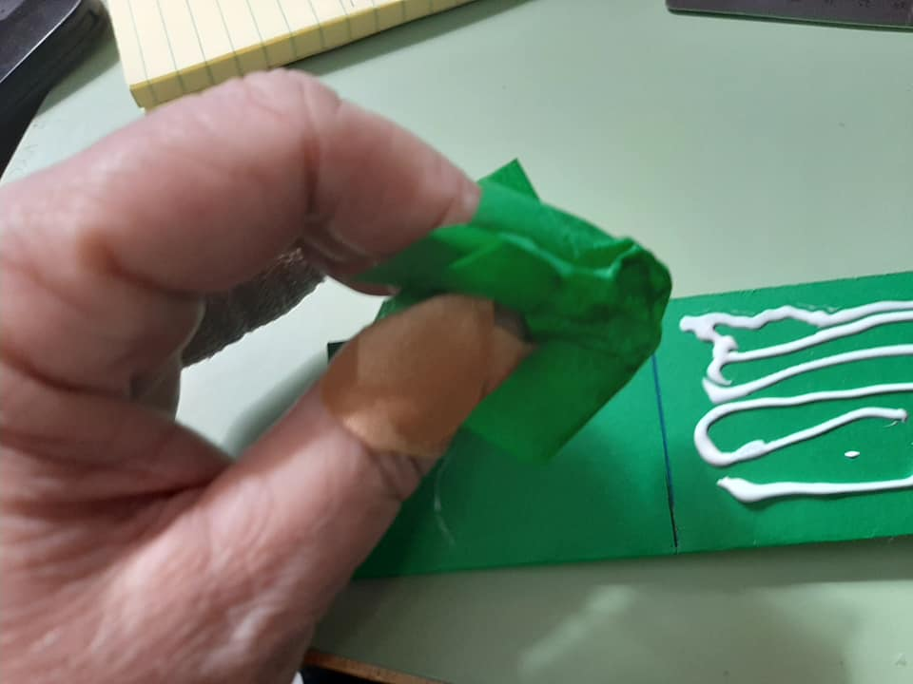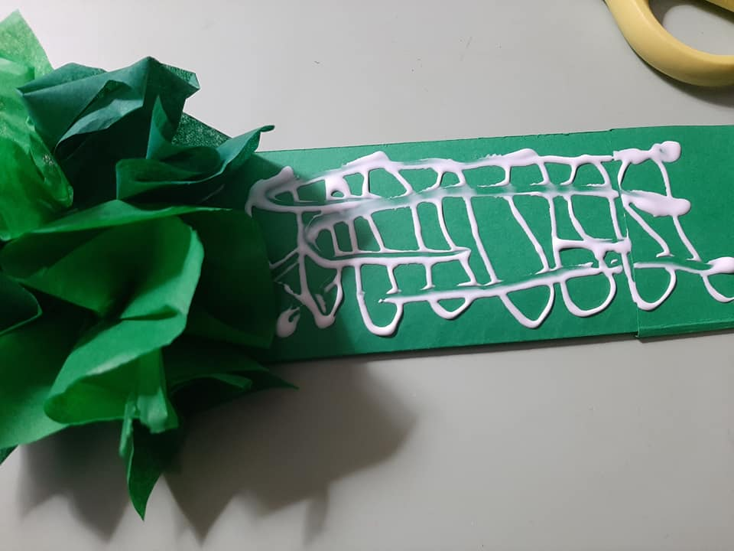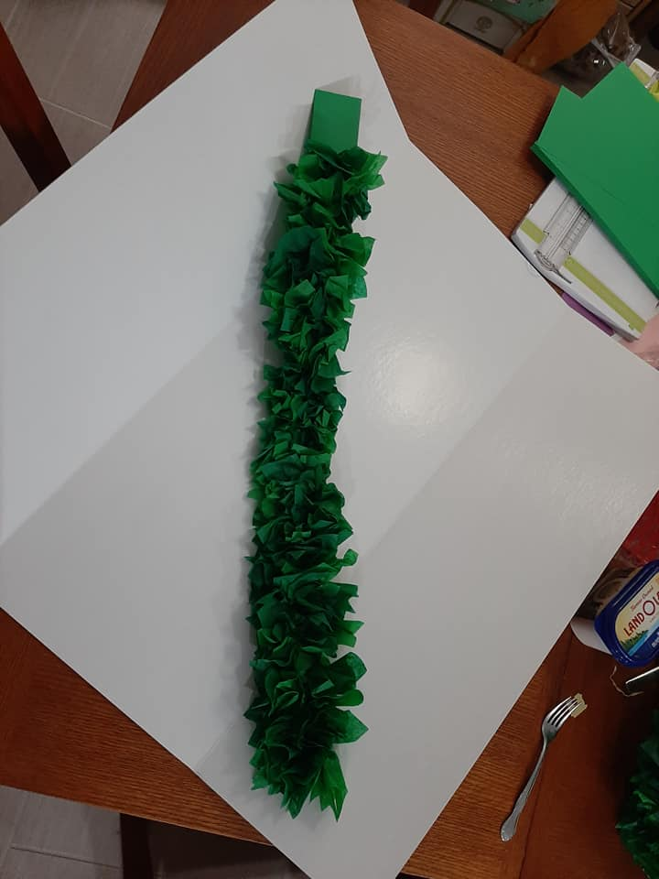

- Form a circle with the strip, overlapping, and glue in place.
Flip the paper plate upside down and put glue just inside the edge.
Put the wreath on the paper plate and into the glue. This forms your base.
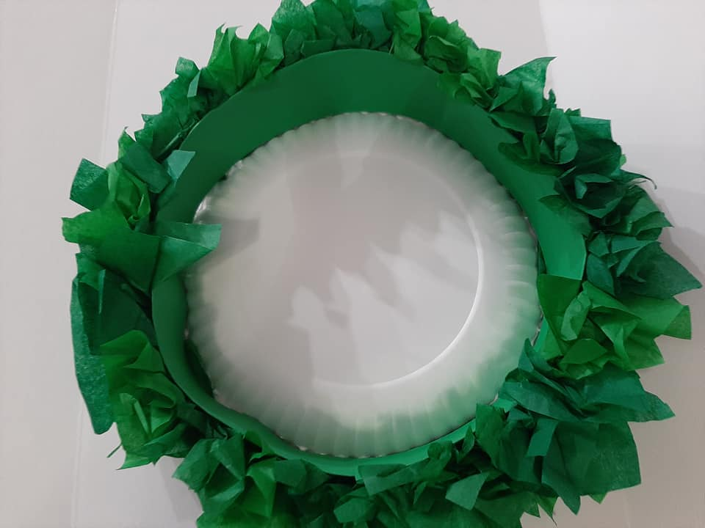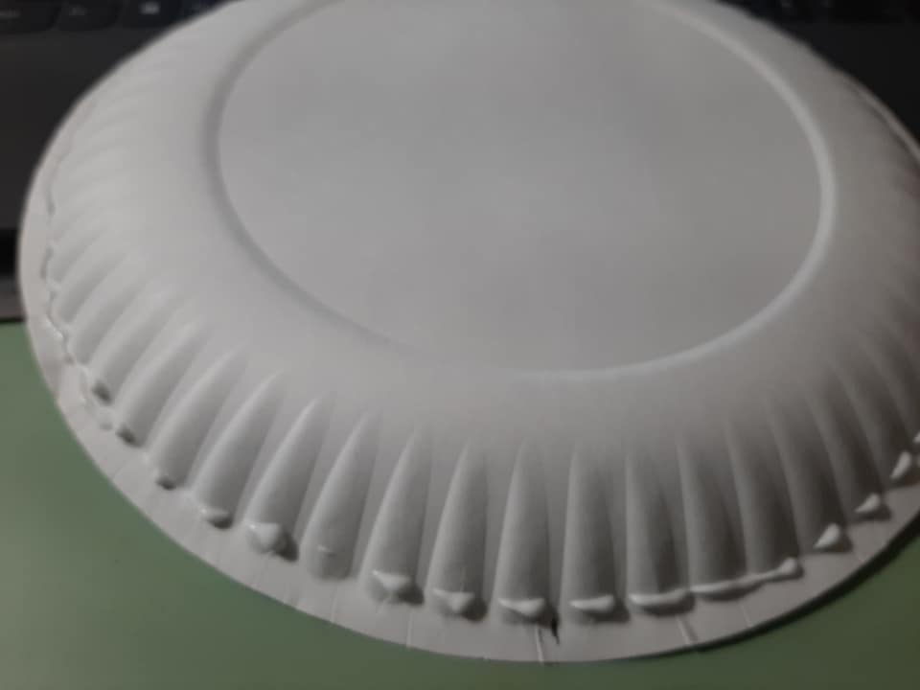

- Now it is time to make the candles for your wreath. We have 5 candles, 3 are purple, 1 is pink, and 1 is white. If you have a taller tube, you can make this the white candle. Do you know why there are 3 purple, 1 pink, and 1 white? I would tell you, but this is a pretty long document, so we can save that for another time!
I will show you how to cover one candle. You will follow the same process for each candle.
Lay out one of the sheets of colored cardstock and spread some glue (not too much, but maybe a little extra at each end). Put the tube on the cardstock, as shown, and roll up to cover the tube. Repeat for the other tubes. If you have one longer tube, that will be the white candle (the Christ candle). If all of your tubes are the same length, that is okay, too.
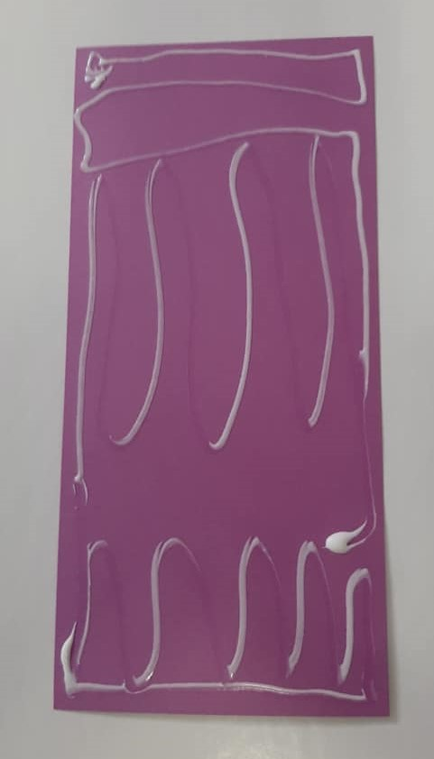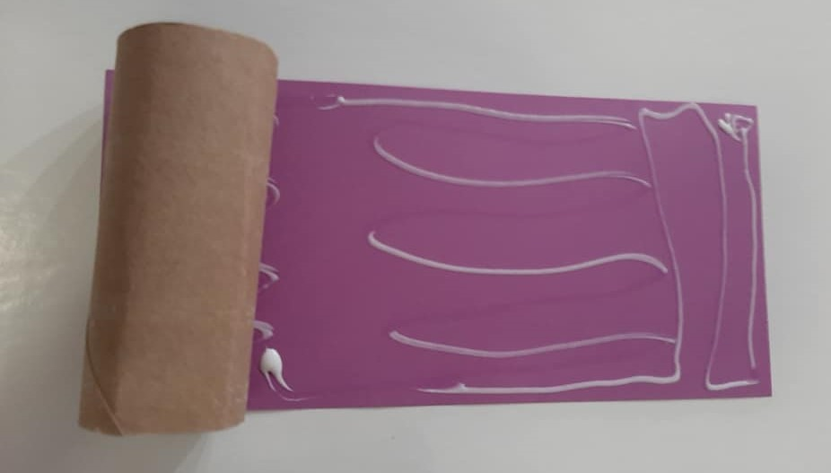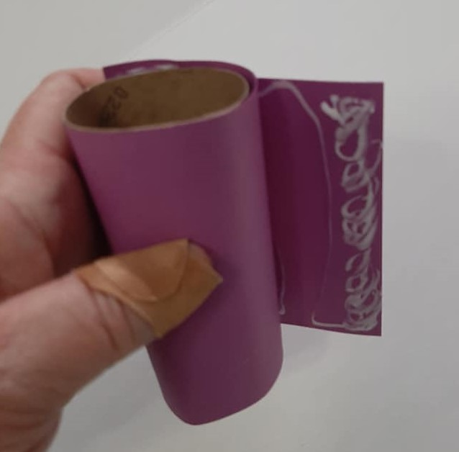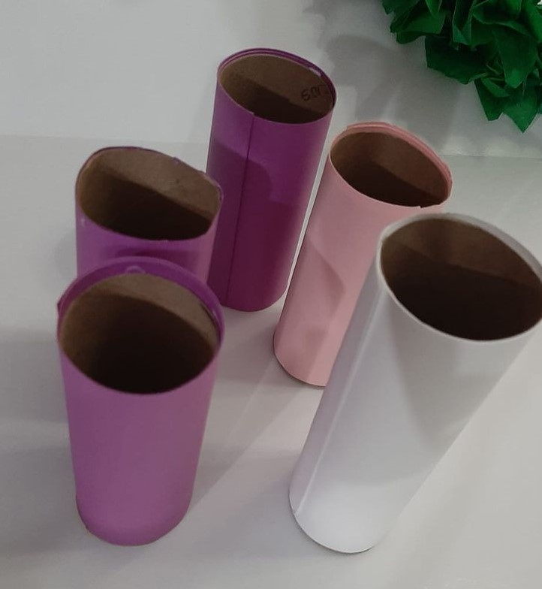

- Now we get to play with fire! Well, not really, of course! Again, the process for each candle will be the same. I will show you one, and you can repeat the process. The 5 2x5 strips of cardstock will hold the flames. Each one will color-coordinate with the candle. Take one strip and hot dog fold it. Mark the folded strip at 1-3/4” from each end. Don’t worry about these marks. They won’t show. Fold on the marks to form a base for the flame. Poke a hole in the middle. Fold a pipe cleaner in half and give it a twist to form the flame. Slide the ends through the hole in the base, and bend the pipe cleaner to fit in the candle. Slide it in. You will just slide it up to “light” it. Don’t try this with a real flame!
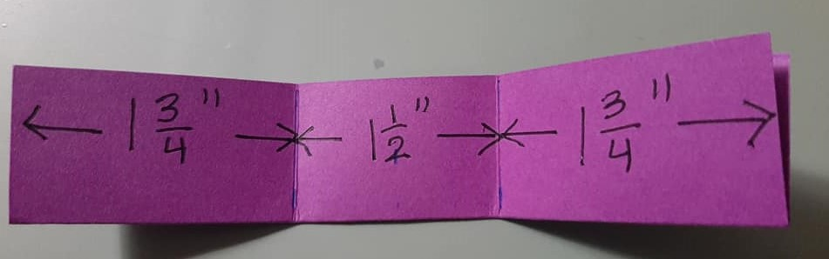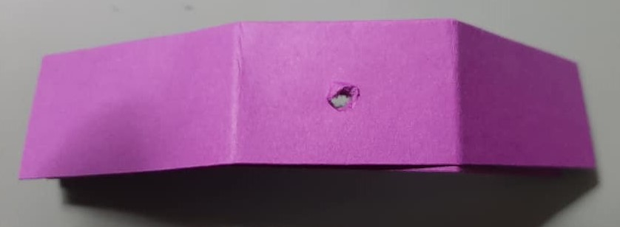

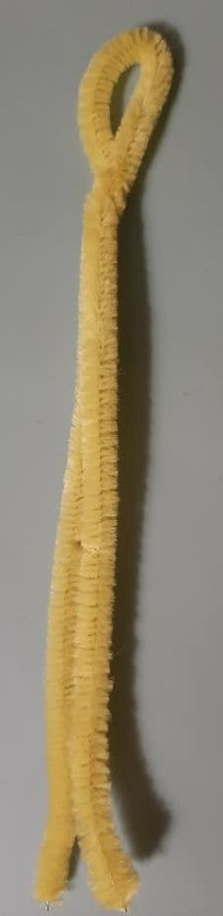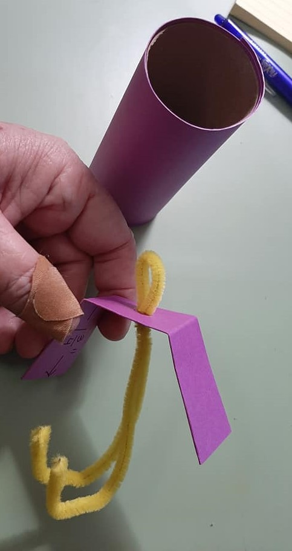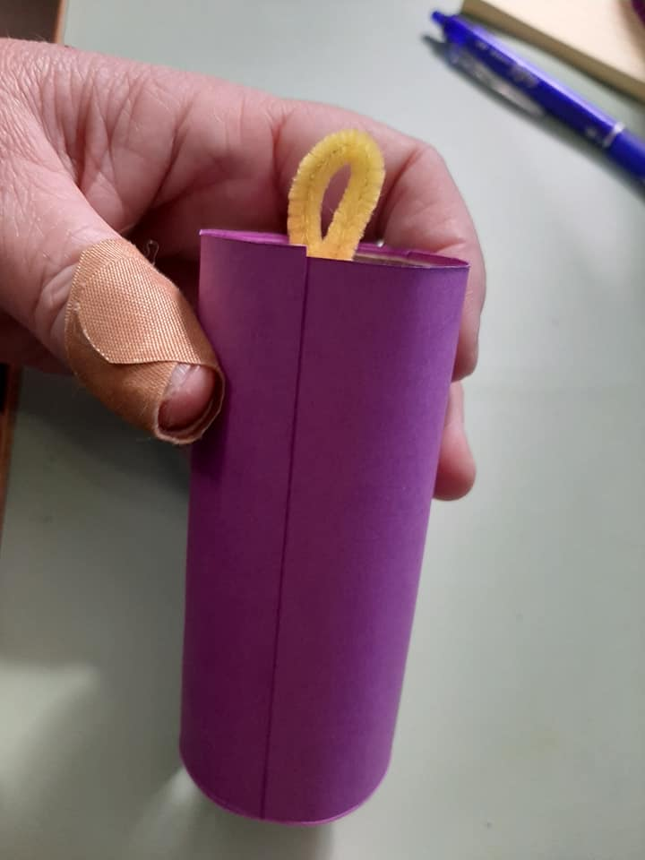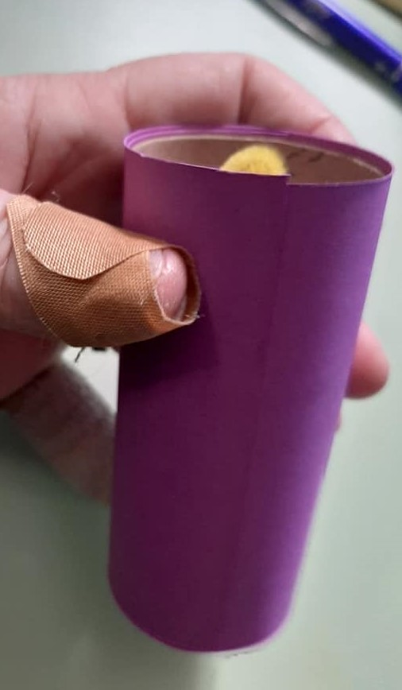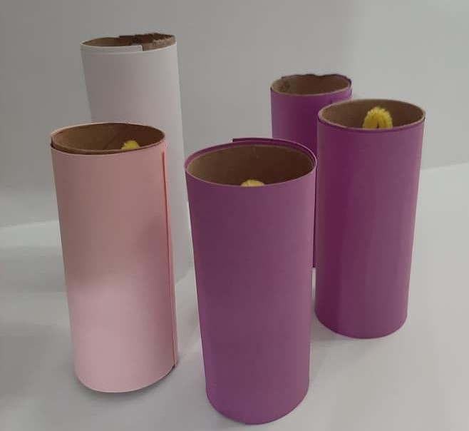

- It is time to put your wreath together! Run a bead of glue along the bottom of each candle. The four outer candles can also have a bit of glue where they meet the wreath circle. Place each candle. Look at what you made! Aren’t you amazing?

